Project Report: Zepto Operational & Sales Performance Analysis
1. Project Overview
- Objective: To uncover insights into delivery performance, spending patterns, and customer segments for Zepto's quick-commerce operations.
- Goal: Guide strategic business decisions regarding operational efficiency and targeted marketing.
- Dataset Summary:
  - Scale: Analyzed 43,326 total orders (compared to 3,900 in the previous shopping project).
  - Key Features: Order Value, Delivery Time, Customer Age, Product Category, City, and Payment Method.
2. Exploratory Data Analysis using Python
We began with data preparation and cleaning in Python:
● Data Loading: Imported the dataset using pandas.
● Initial Exploration: Used df.info() to check structure and df.describe() for
summary statistics.
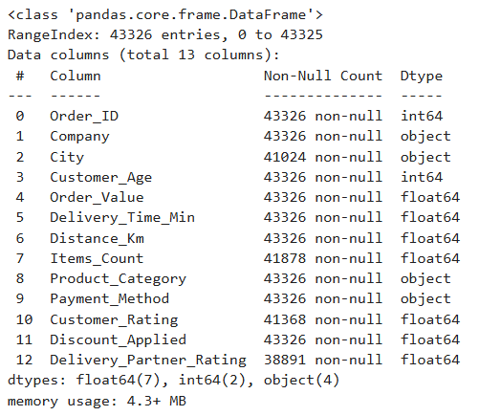
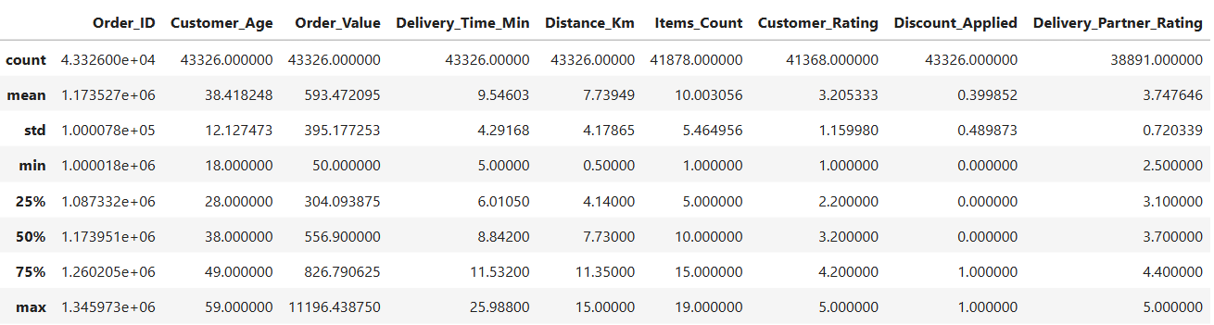Missing Data Handling: Checked for null values and imputed missing values in the
Review Rating column using the median rating of each product category.
Based on the handling of missing values and the structure of your previous project, here is the updated section for your report, including the skewness check:
- City Data Resolution: Conducted a structural cleanup by removing 2,302 records with null values in the City column, as geographical consistency is critical for localized logistics and regional revenue analysis.
- Median Imputation for Ratings: Addressed missing values in Customer_Rating (1,958) and Delivery_Partner_Rating (4,435) by imputing the median; this method was chosen after checking for data skewness, ensuring that outliers in delivery delays did not unfairly bias the service quality metrics.
- Operational Integrity: Applied median imputation to the Items_Count column (1,448 missing) to preserve the dataset's volume for basket-size analysis while maintaining the original distribution of order data.
3. EDA ANALYSIS
basic business KPIs
- Total revenue
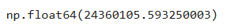

- Average order value
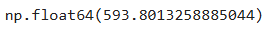
- Total Orders
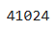

- City-wise Performance
Revenue by City
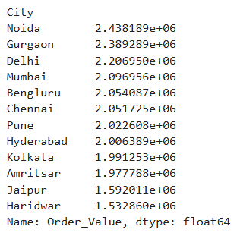
- Avg Delivery Time by City
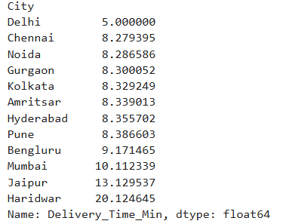
- Average Customer Rating by City
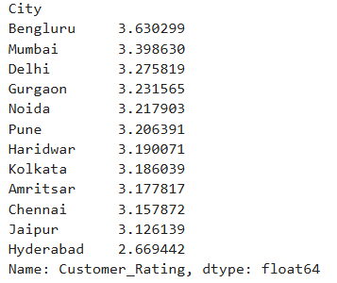

- Discount Impact
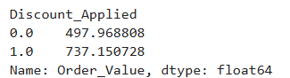
- Correlation Check
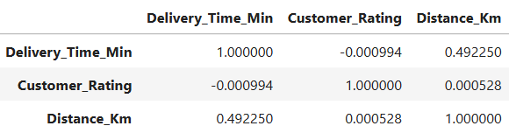

4.Data Analysis using SQL (Business Transactions)
- Which product category contributes the highest revenue?
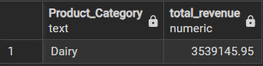

- What is the revenue contribution (%) of each product category?
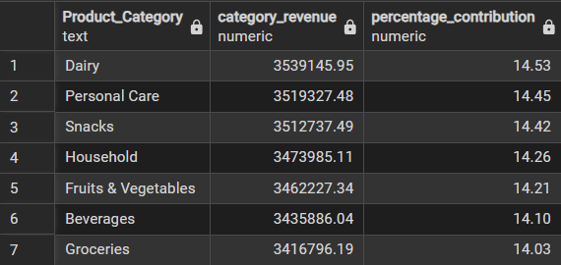

- Which city has the highest average items per order?
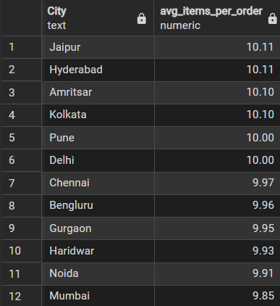
- Compare average rating for fast (<10 min), medium (10–15 min), and slow (>15 min) deliveries.
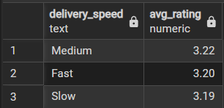
- Does distance range (0–5 km, 5–10 km, >10 km) affect customer rating?
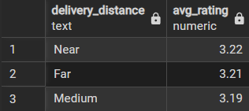
- Which top 3 payment methods are most used?
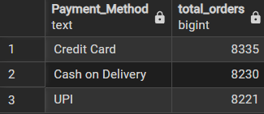
- Does payment method influence average order value?
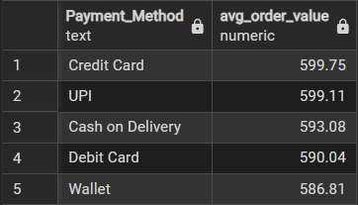
- Which age group (18–25, 26–35, 36–45, 46+) generates highest revenue?
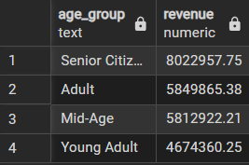

- Identify cities where delivery partner rating is below overall average.
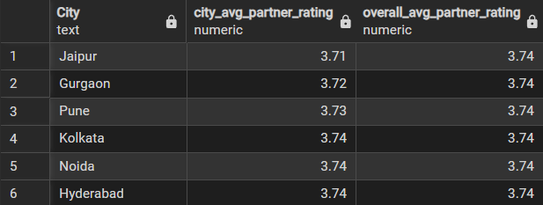
- What percentage of total revenue comes from discounted orders?
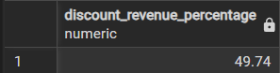
- Top 5 cities by order volume (not revenue).
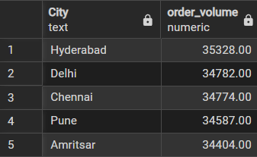
- Is there a relationship between items count and order value? (group into item ranges).
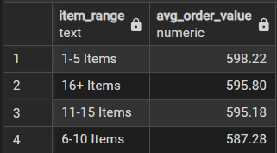
5.Zepto Sales and Delivery Dashboard
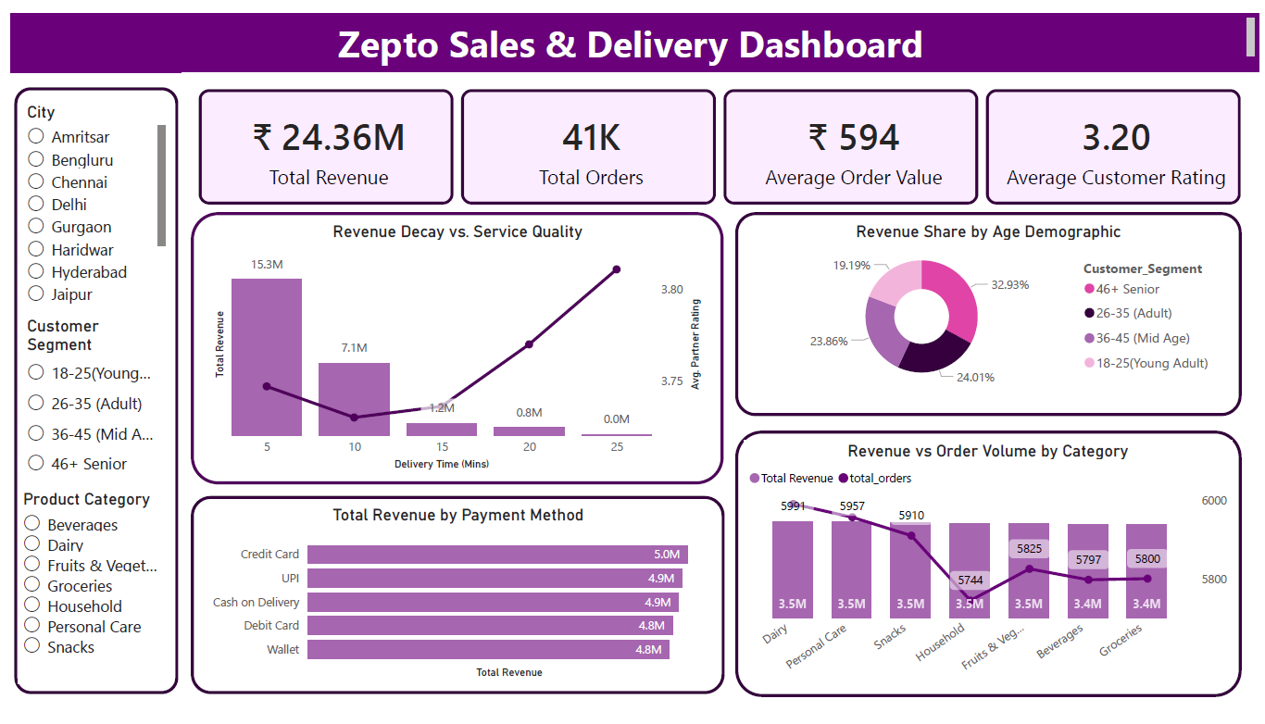
- Interactive Sales & Delivery Dashboard:
Designed to monitor overall business performance by combining sales, order, and delivery metrics in one centralized view for better decision-making.
- Key Performance Indicators (KPIs):
Highlights Total Revenue (₹24.36M), Total Orders (41K), Average Order Value (₹594), and Average Customer Rating (3.20) to give a quick summary of performance.
- Delivery Time Impact Analysis:
Shows how increasing delivery time leads to revenue decline and affects partner ratings, helping improve operational efficiency.
- Revenue by Age Demographics:
Visualizes revenue contribution from different customer age groups to support targeted marketing and customer segmentation strategies.
- Payment Method Analysis:
Compares revenue generated through Credit Card, UPI, Cash on Delivery, Debit Card, and Wallet to understand customer payment preferences.
- Category-wise Revenue vs Orders:
Analyzes product category performance by comparing total revenue and total order volume to identify high-demand segments.
- Dynamic Filtering System:
Includes interactive filters for city, customer segment, and product category to enable customized and real-time data exploration.

